Computer Science 221 Lab 10 Worth: 6 points
[Written by E McDowell and modified by A. Moskol]
Part I: [5 pts] In this laboratory you will write simple programs to experiment with the standard Java string operations. For each method, be sure to input appropriate data to fully test the method, and provide the interactions and output for each method.
Hand in:
- Interaction and output for runs of each of the 5 methods in the appropriate boxes below.
- Either a zip file of your Java program or a complete word document of all the source code. Please be sure to write your name on the Lab.

1. Copy, compile and run the following class, which invokes the concatenate method. This illustrates the use of the length method to find the length of a string and the use of the + operator to concatenate strings. [Please note that you must copy both columns for the complete code for this class]
// Lab 10: Your name  import java.util.*;  public class Lab9App {  private Scanner kbd;  public Lab9App ( ) {  kbd = new Scanner(System.in);  this.doCommands();  }  public void doCommands() {  this.concatenate();  // add appropriate code here  }  public void concatenate( ){  String str1, str2, str3;  int len1, len2;  str1= this.setString ("Enter the first string: ");  str2= this.setString("Enter the second string: ");  len1 = str1.length();  System.out.printf("The length of str1 is %d.%n", len1);  System.out.printf("str1 is \"%s\".%n", str1);  len2 = str2.length();  System.out.printf("The length of str2 is %d.%n", len2);  System.out.printf("str2 is \"%s\".%n", str2);  str3 = str1 + str2;  System.out.printf("str1 + str2 is \"%s\".%n", str3);  } | public String setString( String amessage) {  System.out.printf(amessage);  return kbd.nextLine();  }  public static void main (String[] args) {  new Lab9App( );  }  }  // Expected interaction and output:  [Replace this with at least 2 examples of your own]  Enter the first string: sword  Enter the second string: fish  The length of str1 is 5.  str1 is "sword".  The length of str2 is 4.  str2 is "fish".  str1 + str2 is "swordfish".

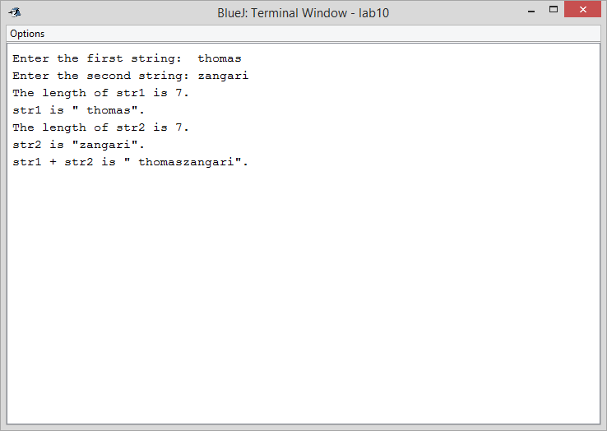

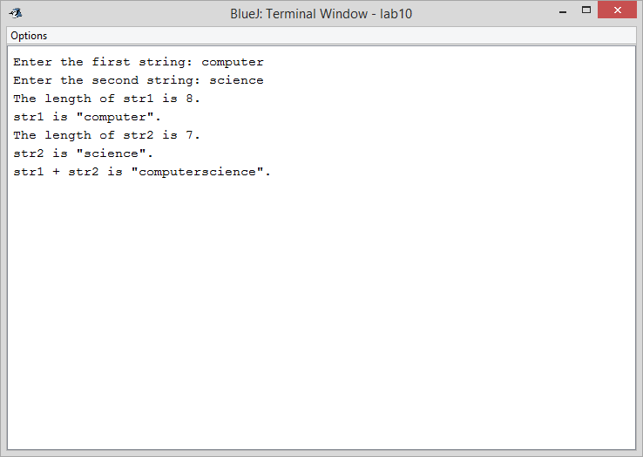

2. Add the following method , compare strings. You will also need to add the appropriate method call. [Note: you can comment this.concatenate(); so you do not repeat this.] .Strings cannot be compared using the usual comparison operators. Instead, the compareTo method is used. The value of st1.compareTo(str2) is negative if str1 < str2, is zero if str1 = str2, and is positive if str1 > str2.

Run the program 3 times with appropriate input so that you illustrates all 3 cases: [Cut and paste the interaction and the output for these 3 runs.]
> [see below]
<
=

public void compareStrings( ){  String str1, str2;  str1 = this.setString ( " Enter the first string: ");  str2= this.setString( "Enter the second string: ");  if (str1.compareTo(str2) < 0)  System.out.printf("%s < %s%n", str1, str2);  else if (str1.compareTo(str2) == 0)  System.out.printf("%s = %s%n", str1, str2);  else if (str1.compareTo(str2) > 0)  System.out.printf("%s > %s%n", str1, str2);  } | // Expected interaction and output:  [Replace this with at least 3 different examples of your own]  Enter the first string: sword  Enter the second string: fish  sword > fish

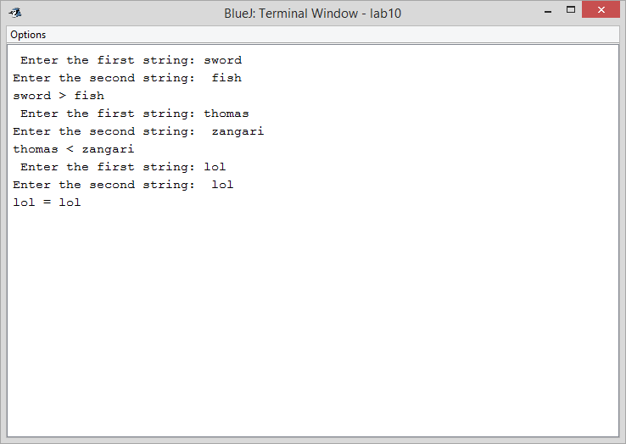

3. Add the following method, searchForSubstrings to illustrate the use of the indexOf method. Compile and call this method twice: once when the target was found (as show below) and another time when the target was not found. Cut and paste both interactions.

public void searchForSubstrings( ){  String source, target;  int posn;  source = this.setString ("Enter the source string: ");  target = this.setString("Enter the target string: ");  posn = source.indexOf(target);  if (posn < 0)  System.out.printf("The target was not found.%n");  else  System.out.printf  ("The target was found at position %d.%n", posn);  } | // Expected interaction and output:  [Replace this with at least 2 examples of your own]  Enter the source string: parenthesis  Enter the target string: rent  The target was found at position 2.

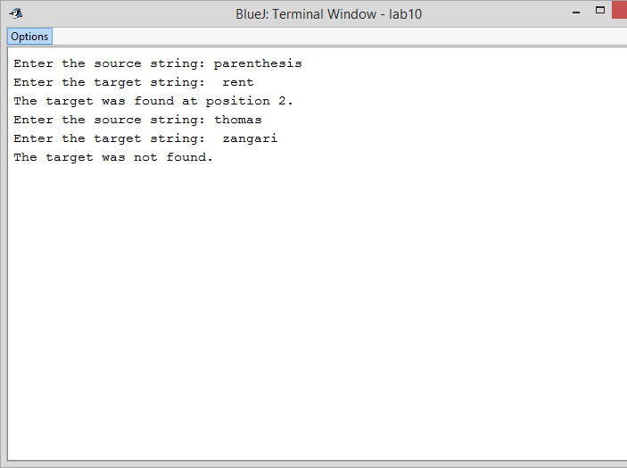
4. Add the following method, extractSubstrings() which illustrates the use of the substring method to extract substrings. The first argument to substring is the index of the first character of the substring. The second argument is the index of the character following the substring. substring returns the string between these indices.

Invoke this method several times and show the sample interaction and output.

public void extractSubstrings( ){  String str, substr;  int start, finish;  str = this.setString ("Enter the string: ");  System.out.printf("Enter the starting position: ");  start = kbd.nextInt();  System.out.printf("Enter the ending position: ");  finish = kbd.nextInt();  substr = str.substring(start, finish);  System.out.printf("The substring is \"%s\".%n", substr);  } | // Sample interaction and output: [Replace this with at least 2 examples of your own]  Enter the string: parenthesis  Enter the starting position: 2  Enter the ending position: 6  The substring is "rent".
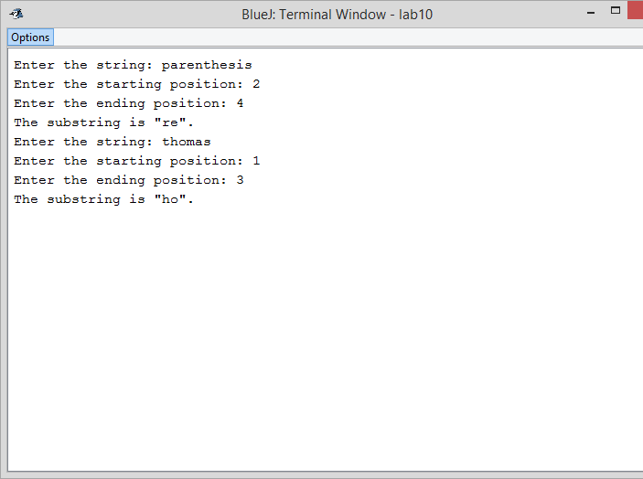

5. Add the following method, replaceSubstrings() that uses the replace method to replace all occurrences of one substring with another. The first argument is the substring to replace. The second argument is the replacement string.

public void replaceSubstrings() {  String str, oldstr, newstr;  str =setString ( "Enter the string: ");  oldstr = this.setString(“Enter the substring to replace: ");  newstr= this.setString( “Enter the replacement string ");  str = str.replace(oldstr, newstr);  System.out.printf("The new string is \"%s\".%n", str);  } | // Sample interaction and output [Replace this with at least 2 examples of your own]  Enter the string: It's a dog eat dog world.  Enter the substring to replace: dog  Enter the replacement string: wolf  The new string is "It's a wolf eat wolf world."

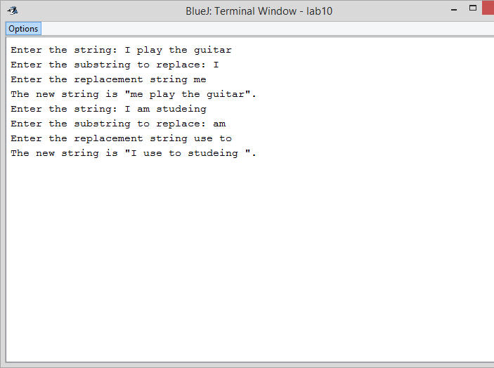
Lab #9 Part II. Worth: 1 point Name: ___thomas zangari______________

1) Determine the Output from the following:
String str = "abc";  String cde = "cde";  System.out.println("abc" + cde);  String c = "abc".substring(2,3);  String d = cde.substring(1, 2);  System.out.println (c + d); | cd

2) Determine what the following methods return:
"unhappy".substring(2) returns  "Harbison".substring(3) returns  "emptiness".substring(9) returns  "hamburger".substring(4, 8) returns  "smiles".substring(1, 5) returns | Happy  ison  urge  miles

3. [From Horstsmann, p. 130]
a) String s = “Agent”;
s= s + s.length( ); What is the value of s?
Agent5

b) String river = “Mississippi”;
System.out.println(river.substring(1,2)); Output:i
System.out.println(river.substring(2, river.length() - 3)); Output:
ssissi

